CMPG322
Practical exercise 3.2 – Forecasting for trend and random variations, monitoring an controlling forecasts
- Passenger miles flown on Northeast Airlines, a commuter firm serving the Boston hub, are as follows for the past 12 weeks:
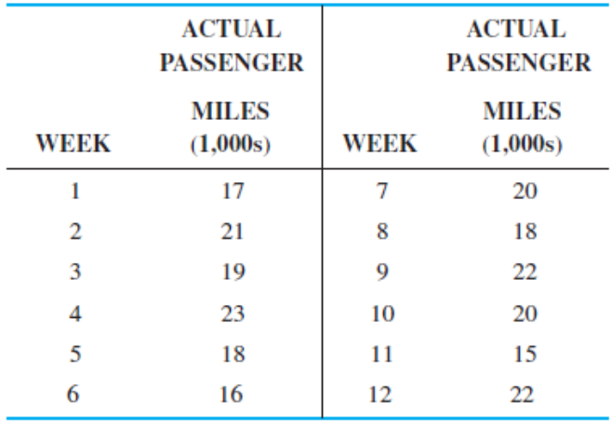
- Assuming an initial forecast for week 1 of 17,000 miles, use exponential smoothing to compute miles for weeks 2 through 12. Use a = 0.2.
- What is the MAD for this model?
- Compute the RSFE and tracking signals. Are they within acceptable limits (limit = 4 MADs)?

- The following table provides the Dow Jones Industrial Average (DJIA) opening index value on the first working day of 1994–2013.
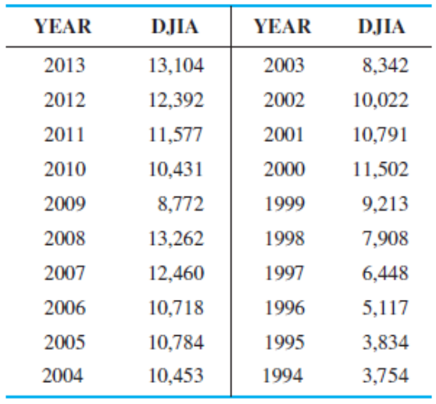
- Develop a trend line and use it to predict the opening DJIA index value for years 2014, 2015, and 2016.
- Find the MSE for this model.
- Using exponential smoothing with trend adjustment, forecast the opening DJIA value for 2014. Use α = 0.8 and β = 0.2.
- Compare the MSE for this technique with the MSE for the trend line.
- Use an exponential smoothing model with a smoothing constant of 0.4 to predict the opening DJIA index value for 2014.
- Find the MSE for this model.
- Use QM for Windows or Excel to find the smoothing constant (one decimal) that would provide the lowest MSE.

- The following table gives the average monthly exchange rate between the U.S. dollar and the euro for 2009.
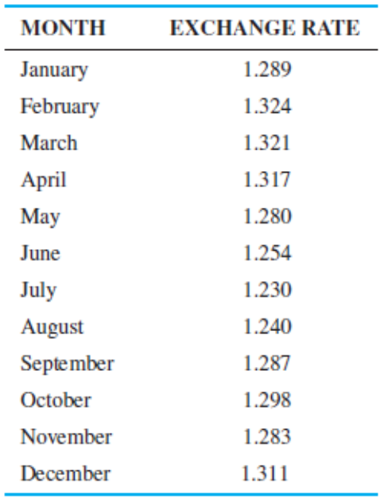
It shows that 1 euro was equivalent to 1.289 U.S. dollars in January 2009.
- Develop a trend line that could be used to predict the exchange rate for 2010.
- Use this model to predict the exchange rate for January 2010 and February 2010.
- Develop an exponential smoothing model with a smoothing constant of 0.3.
- Using the MSE, compare this with the model in a).
- Using exponential smoothing with trend adjustment (including a tracking signal), forecast the exchange rate for January 2010 using α = 0.9 and β = 0.5. Assume a perfect forecast for January 2009.
- Compare the MSE for your answer in e) with your previous answers.
- Compute the RSFE and tracking signals. Are they within acceptable limits (limit = 4 MADs)?

